Are you afraid of flying?  - Want to overcome this fear?  This group is for you!  Begins Wednesday, September 19th, 2018  A 6-week course designed to address the common reasons flying is terrifying for so many, followed by an (optional) flight on a commercial airplane  Fees: $300 for initial course (7pm – 8:30pm at ASDI, Rm 212)  $400 + airfare for flight (Saturday, Nov 3rd)  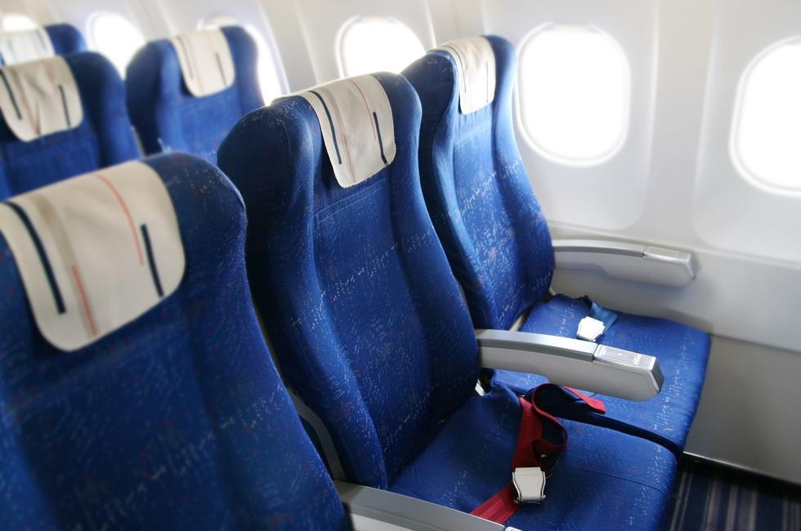  Questions? Contact Stephnie Thomas at 410-236-1470 or stephniet@stephthomas.com. Initial evaluation required prior to entering group | Contact Stephnie Thomas  410-236-1470  Contact Stephnie Thomas  410-236-1470  Contact Stephnie Thomas  410-236-1470  Contact Stephnie Thomas  410-236-1470  Contact Stephnie Thomas  410-236-1470  Contact Stephnie Thomas  410-236-1470  Contact Stephnie Thomas  410-236-1470  Contact Stephnie Thomas  410-236-1470  Contact Stephnie Thomas  410-236-1470  Contact Stephnie Thomas  410-236-1470  Contact Stephnie Thomas  410-236-1470  Item  Stephnie Thomas  Item  Stephnie Thomas  Item  Stephnie Thomas

